Test log sheets
Candidate: Jayden-James Wilson Project title: Airline – Distinct

Test case | Test data | Expected result | Actual result | Comments
List of options |  | Show a list of available options | You can show a list of available options | 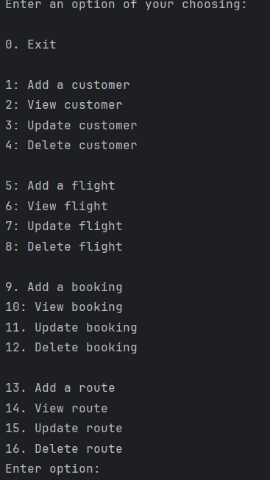
Create booking | booking id: b1  customer id: c5  Customer id: c1  flight id: f5  flight id: f2  booking date: 23/12/12 | . add a new booking and be able to reference existing flights and customers | You are able add a new booking and be able to reference existing flights and customers | 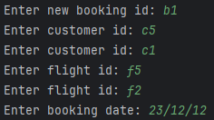  If a booking with the same id you will be asked to enter a new different one.  If a flight or customer doesn’t exust you will be asked to enter id that do.
Update booking | booking id: b1  Customer id: c2  flight id: f2  booking date: 14/12/12 | . update existing booking and be able to reference existing flights and customers | You are able to update booking and be able to reference existing flights and customers | 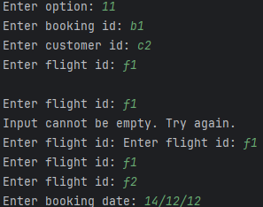  Will only let you update customer where the id exists  If a flight or customer doesn’t exist you will be asked to enter id that do.
View Booking | Booking id: b1 | View details of existing booking | You are able to view details of existing booking | 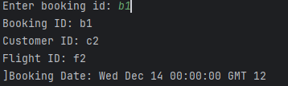  Will only let you view booking where the id exists
Delete booking | Booking id: b1 | Should delete existing booking | Does delete existing booking | Will only let you delete customer where the id exists
Add customer | customer id: c1  customer name: jayden  customer last name: wilson  customer email: jayden@mail.com  customer phone: 0987654  customer address: DH726HW | Should be able to add a new customer | You can add a new customer | 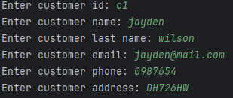  If a customer with the same id you will be asked to enter a new different one.
Update customer | Customer id: c1  customer name: jayden-james  customer last name: wilson  customer email: jayden@mail.com  customer phone: 2345678  Enter new customer address: BS636DY | Should be able to update an existing customer | You can update existing customer | 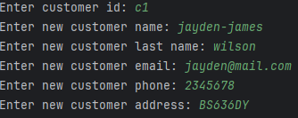  Will only let you update customer where the id exists
View customer | Customer id: c1 | Should be able to view existing customer | You are able to view existing customer | 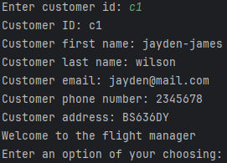  Will only let you view customer where the id exists
Delete Customer | Customer id: c1 | Should be able to delete existing customer | You can delete existing customer | Will only let you delete customer where the id exists
Add flight | flight id: f1  flight number: flight101  departure airport: ABDN  arrival airport: LODN  departure date: 26/05/2024  arrival date thats after departure date: 24/05/2024  arrival date thats after departure date: 26/05/2024 | Should be able to add a flight | You can add a new flight | 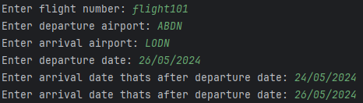  Will only let you put in a date on or after the departure date  If a flight with the same id you will be asked to enter a new different one.
Update flight | flight number: flight102  departure airport: ABDN  arrival airport: LODN  departure date: 25/05/2025  arrival date: 25/05/2025 | Should be able to update flight | You can update flight | 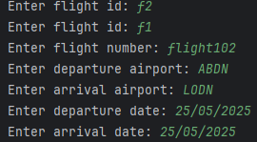  Will only let you update flight where the id exists
View flight | Flight id :f1 | Should be able to view specific flight | You can view specific flight | 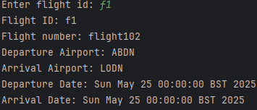  Will only let you view flight where the id exists
Delete flight | Flight id: f1 | Should be able to delete a specific flight | You can delete a specific flight | Will only let you delete flight where the id exists
Add route | route id: route2  route name: route202 | Should be able to add a new route | You can create a new route | 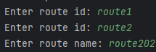  If a route with the same id you will be asked to enter a new different one.
Update route | route id: route2  route name: route203 | Should be able to update specific route | You can update specific route | 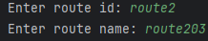  If a route with the same id you will be asked to enter a new different one.
View route | route id route2 | Should be able to view specific route | You can view specific route | 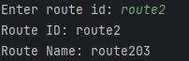  If a route with the same id you will be asked to enter a new different one.
Delete route | Route id: route2 | Should be able to delete specific route | You can delete specific route | If a route with the same id you will be asked to enter a new different one.
Customers to CSV |  | Should be able to export customer list as a CSV file | You can export customer list as CSV | 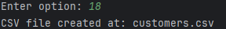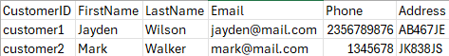
Flights to CSV |  | Should be able to export flight list as a CSV file | You can export flight list as CSV | 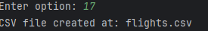
Bookings to CSV |  | Should be able to export booking list as a CSV file | You can export booking list as CSV | 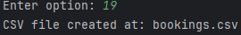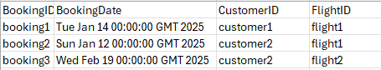
Routes to CSV |  | Should be able to export route list as a CSV file | You can export routes list as CSV | 